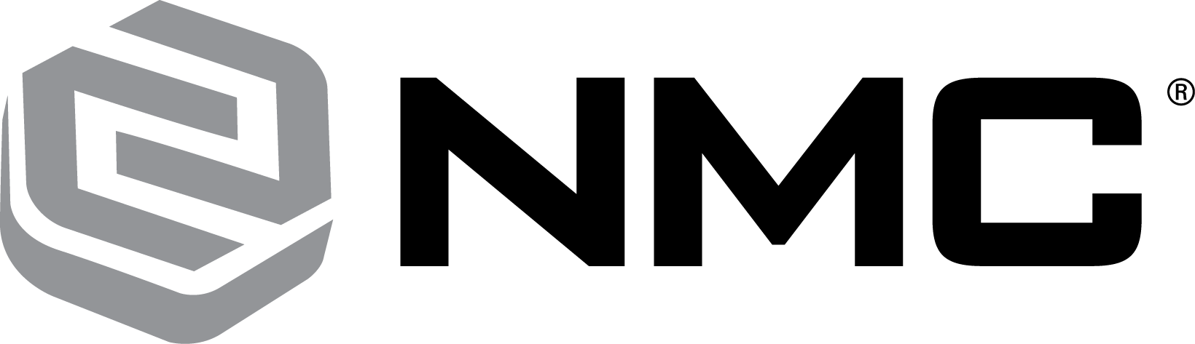

NMC STUDENT SPONSORSHIP PROGRAM

For over 20 years, NMC has partnered with Diesel Technology schools in the Midwest, offering a premier sponsorship opportunity for students interested in pursuing a career in the Heavy Equipment industry. In collaboration with the Midwest’s finest Diesel Technology schools, our program includes:

- Paid tuition, books, fees, and NMC branded uniforms (up to a $10,000 value)
- Two paid summer internships
- Toolbox and tools set (up to a $6,000 value)
- Personalized mentoring and guidance over the course of the program
- Opportunity to earn an Associates of Applied Science Degree in Diesel Technology
- Employment and career progression opportunities with NMC

For additional information on each of the programs and to submit your application, please visit us at nmc-corp.com/students

